**Database Description and Business Rules**

Customers have to register to the system in order to make a booking for a room. Each user must enter a name, email, phone Number, address, and password in order to be authenticated. After registration the user can select room categories which have the following categories, room-type, rooms-available, room-size, price, capacity among others. Using these properties, the user can be able to filter the categories according to their need.

After selecting a room-category the user is required to enter the check-in and checkout date and then make a payment in which the user id, reservation-id and amount paid are recorded once the payment is successful. The user can only make a booking when they are logged in. After that a user is assigned a room from that room category selected. Once a room as been assigned to a user its status changes to reserved. Once a user checkout the room status changes to Available and also reservation state changes to checked-Out.

**NoSQL Database Model**

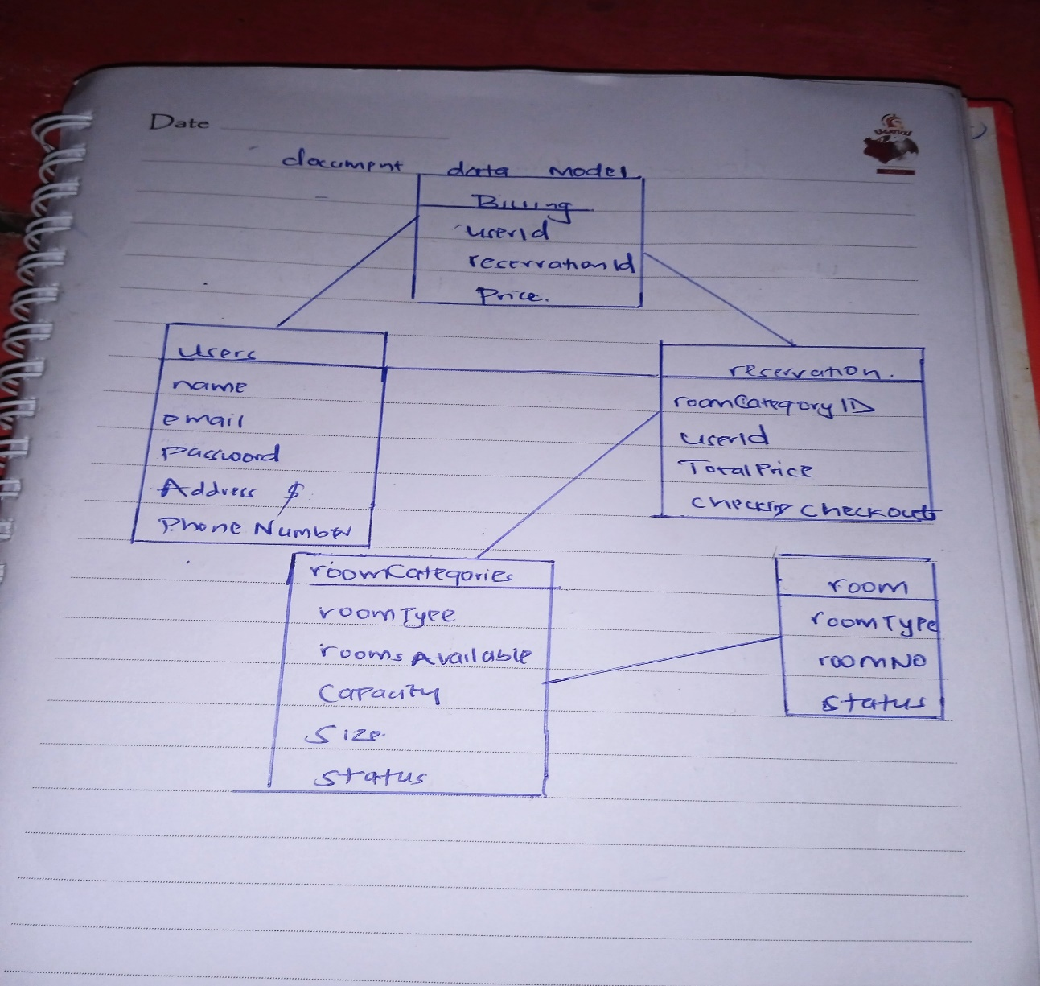

**Document-Based Store(JSON File): All data is stored in a document, so there’s no need for cross-referencing and instead of storing information in a table, it’s stored in a document.**

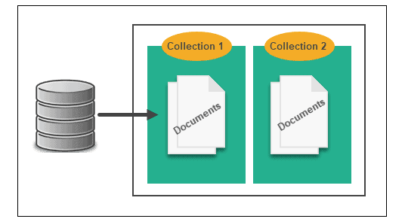

**Collection 1 users contains:**

name,

email,

phoneNumber

address

passsword

**collection 2 roomCategory** contains

roomType

roomPrice

roomsAvailable

roomImages

**collection 3 Reservations** contains

roomNo

roomCategoryId,

checkIn

chekout

totalPrice

userId

**collection 4 rooms** contains

roomCategoryId

status

roomNo

roomType

**collection 5 billing** contains

userId

reserVationId

cash

status

**Database Diagram**

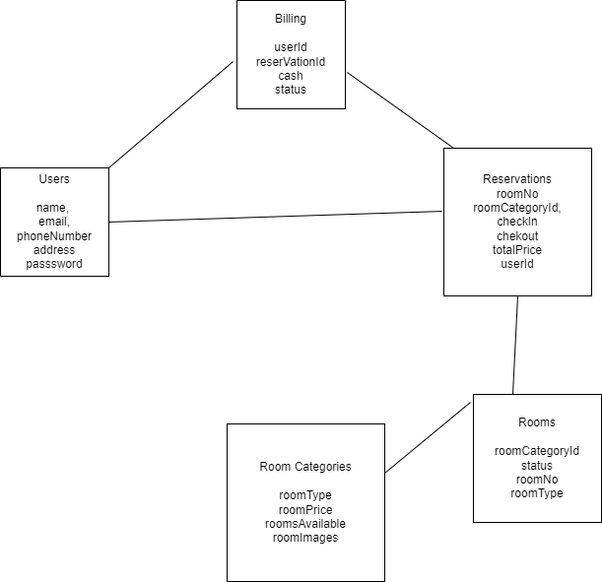

Users Collection

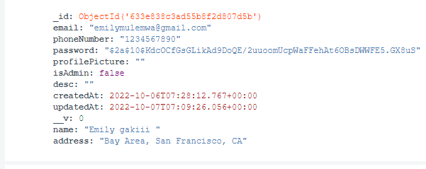

roomCategories

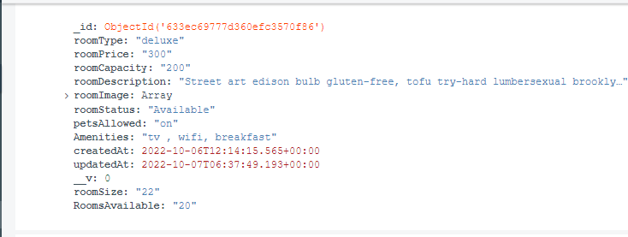

Rooms

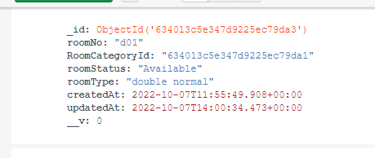

Reservation

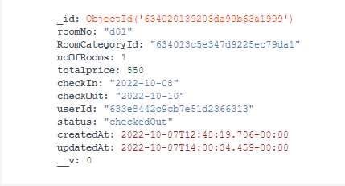

**Graph Database Model**

